February 1, 2017

Dear Property Owner:
I want to thank everyone who attended the Landlord Lunch N’ Learn meeting on January 24th. It was great to see everyone there.
The following items were covered at the meeting:
Effective January 1, 2017, carbon monoxide detectors are required in every unit with a gas fired appliance or an attached garage on every habitable floor. Habitable is defined as a floor used for living, sleeping, eating, or cooking. Basement laundry and/or bath rooms without living quarters or unoccupied attics would not need a carbon monoxide detector. The City prefers that the carbon monoxide detector is installed outside the bedrooms if possible.
New Lease Requirements – We are now required to have the signed Housing Assistance payments Contract returned to our office before we can mail out any payments. As soon as we receive the contract we will mail out the rental payment or process for Direct Deposit.
Rent Increases – the landlord needs to send a rental increase notice to the Housing Authority at least 60 days in advance. If the rent notice is received 60 days in advance the Housing Authority will update the rent increase if it meets rent reasonableness. If it is not received timely the rental increase will be processed the following month. According to the Housing Assistance Payments Contract the landlord cannot charge the tenant the additional rent.
Additional HAP Payments – any time there is a change of income of $400 or more annually an adjustment will be made after verification of the income. If the Housing Authority is notified by the tenant at the end of the month of a job loss for instance HHA must verify the information before an adjustment can be made. The previous month HAP payment will be sent and then an additional HAP payment will be sent once the information is verified and proper rent allocations can be determined.
Tenant Screening – just a reminder that the Housing Authority does not screen a tenant for rental suitability but only to determine if they are eligible for the Housing Choice Voucher Program. Since every landlord has a different screening criteria please make sure the tenant meets your qualifications.
Unit Transfers – if you would like to transfer the tenant to another unit, the housing authority will need at least 30-day’s notice to ensure that a recertification of income and assets can be completed prior to the move. Even though the new unit may have been previously occupied by a housing authority tenant the unit must pass Housing Quality Standards (HQS) inspection before the new tenant can receive assistance in this unit.
HQS Emergency Fail Items – Housing Quality Standards requires 24 hours resolution to any deficiency that puts the tenant family’s well-being at immediate risk. Examples of this type of Emergency fail item includes but is not limited to: if a unit does not have the ability to maintain adequate heat, there is a major plumbing leak, natural gas leak, exposed electrical wire that could result in shock or fire, a security risk such as a broken door or window or the only toilet in the unit is unusable. All of these would be considered items that must be fixed within 24 hours or the Housing Authority would have to abate payment. Abatement means that you will not receive payment from the housing authority for the entire time that the unit is not in compliance with HQS. The tenant is not responsible for the Housing Authority’s unpaid rent during the abatement period.
Housing Improvement Partnership Conference –The Nebraska Chapter of NAHRO and the City of Grand Island are partnering to present the Housing Improvement Partnership Conference in Grand Island, April 19, 2017 with registration starting at 9:30 a.m. The Conference will be held at the Hotel Grand, located at 2503 S Locust Street in Grand Island. Although still in the planning phase there will be three tracks, a Neighborhood Track, Housing & Development Track and a Public Housing Track. The cost to attend the conference is $100 and there maybe Scholarships available if you would like to attend. Please contact Leanna if you would like a scholarship.
Landlord Listing – the Housing Authority has inquiries daily for landlords that have rental units in the community. A landlord list is maintained at the office. If you would like to be included on this list, please contact the office with the company name and phone at 402-463-1061.
Form W9 – Enclosed with your check is a Form W-9 that needs updated and returned to our office or you can mail in the enclosed business reply envelope. This document is used to complete the Form 1099 that the Housing Authority is required to send if you receive payments over $600 in a year.
Direct Deposit – The Housing Authority is planning to implement Direct Deposit for landlord payments effective March 1, 2017.
Direct deposit offers you many benefits, including:
- Quicker delivery of your payment because you don’t have to wait for a mailed HAP check to reach you.
- It eliminates the possibility of lost, stolen, or forged checks
- It saves you time because you do not have to make a trip to the bank to deposit your check.
- Fast and easy access to your payment information online using a secure, password-protected account.
The Housing Authority website is currently being updated. If you are planning on utilizing direct deposit you can access your HAP statement online at www.hastingshousingauthority.com. This online system, called HMS PAL (Payment Access for Landlords), offers fast and secure access to your payment information. It provides 18 months of payment history, current year to date totals, and tenant payment details, including tenant addresses. Your most current direct deposit payment data will be available online on the day following the processing of your housing assistance payment. Since HUD sends the money to the housing authority on the first business day of the month except for federal holidays, our goal is to have the payments available to you on the 3rd business day of the month, if not sooner. You will have the option to receive monthly e-mail notifications that your HAP statement has been posted online if you provide your e-mail address on the enrollment form. Enclosed with your check this month is a Direct Deposit Authorization form. Please complete the authorization and attach a voided check (the bank will not accept deposit slips) and either mail in the enclosed business reply envelope or drop at the office between 8:00 – 12:00 and 1:00 – 5:00 Monday thru Friday.

You will be required to register on the landlord portal once you have been notified by email that you have a payment. The landlord portal is pictured below and can be accessed either thru www.hastingshousingauthority.com or directly by going to the following web site: www.pal.hmsforweb.com.
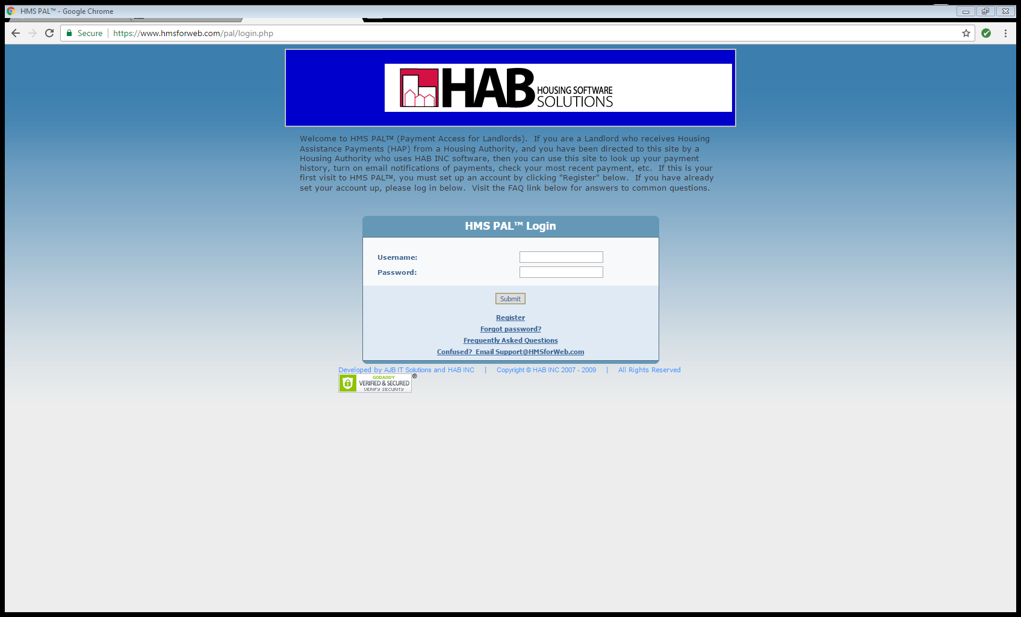
Register
Here

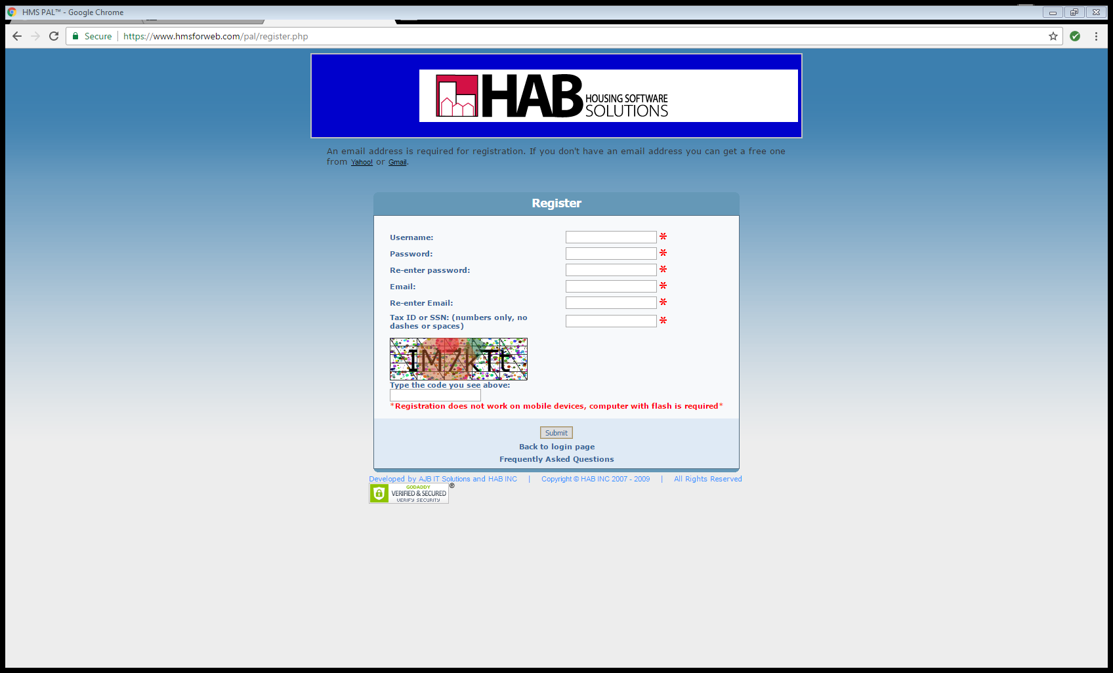
Complete this information and submit to register
Complete the information above and select submit. You will then be registered on the site and can access your payments. For security purposes, you cannot register until the first payment has been sent, to ensure that the only people on the site are actual landlords checking payments.
We very much appreciate our continued relationship with all of you. We are unable to provide decent, safe and sanitary housing to the low income families in this community without your participation and cooperation.
Please don’t forget to sign up for direct deposit and return the enclosed Form W-9. Should you have any questions or concerns please contact Leanna Pollock, the program supervisor at 402-463-1061.
Sincerely,

Jeanne Leick
Deputy Director/Agent

Encl.

